- Select the local lease agreement for your area. We have consolidated these so that it is easier for you to find the agreements as well as the governing body.
- 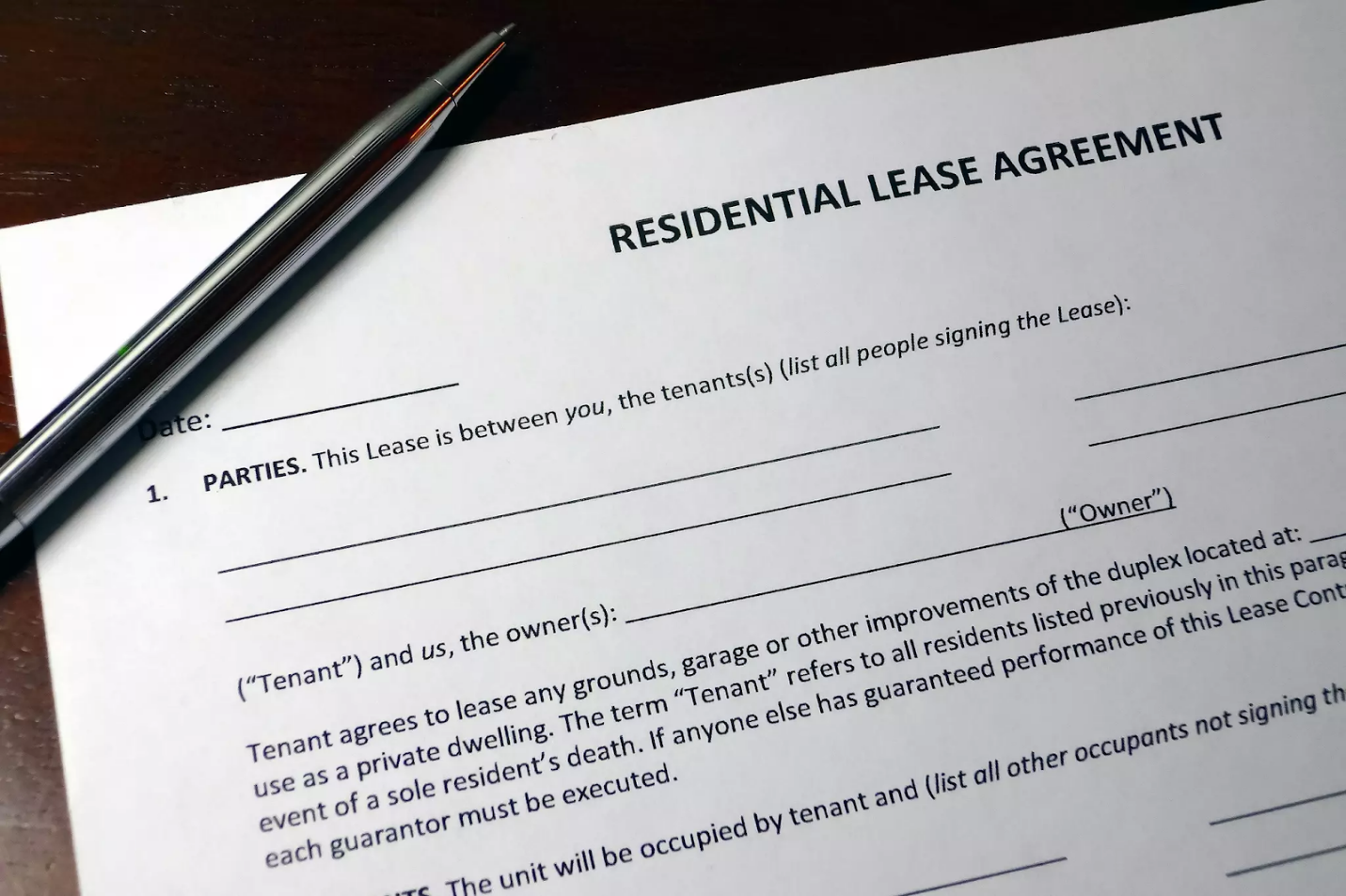
- TEXT & IMAGES
- Edit
- Canada
- British Columbia
  - Guide For Landlord and Tenants
  - Residential Tenancy Agreement
  - Residential Tenancy Act
  - - BC
- Alberta
  - Guide For Landlord and Tenants
  - Laws for Landlords & Tenants
  - Residential Tenancy Act
  - - AB
- Saskatchewan
  - Guide for Landlord & Tenants
  - Example Leases
  - Residential Tenancy Act
  - - SK
- Manitoba
  - Guide For Landlord and Tenants
  - Residential Tenancy Agreement
  - Residential Tenancy Act
  - - MB
- Ontario
  - Guide For Landlord and Tenants
  - Residential Tenancy Agreement
  - Residential Tenancy Act
  - - ON
  - Tribunals Ontario
- Quebec
  - Guide For Landlord and Tenants
  - Residential Tenancy Agreement
  - Residential Tenancy Act
  - - QC
  - Tribunals Quebec
- Newfoundland
  - Guide For Landlord and Tenants
  - Residential Tenancy Agreement
  - Residential Tenancy Act
  - - NF
- New Brunswick
  - Guide For Landlord and Tenants
  - Residential Tenancy Agreement
  - Residential Tenancy Act
  - - NB
- Prince Edward Island
  - Guide For Landlord and Tenants
  - Residential Tenancy Agreement
  - Residential Tenancy Act
  - - PE
- Nova Scotia
  - Guide For Landlord and Tenants
  - Residential Tenancy Agreement
  - Residential Tenancy Act
  - - NS
- View more
- TEXT & IMAGES
- Edit
- United States Residential Lease Agreements
- This links you to
- guides for every state
- (in blue), so landlords and tenants across the nation are informed of their local laws.
- TEXT & IMAGES

